Name: Pranali Sonawane
Subject: CCNA
Date: 15-11-2025
Lab – EIGRP Configuration(Load Balancing) :
First, take two routers (e.g., 1841), two switches, and four PCs. Connect the routers, switches, and PCs using straight-through cables. Also, connect the serial interfaces using a straight-through cable and connect the FastEthernet interfaces using crossover cables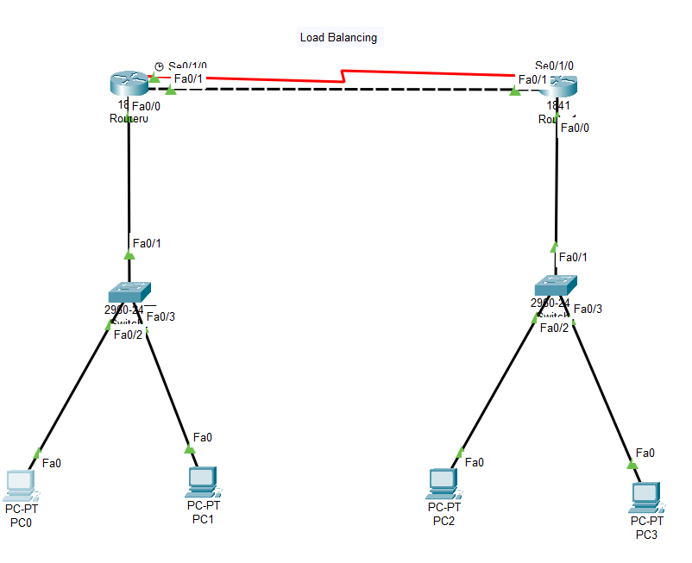
Serial cable:
Open Router 0 – CLI prompt then type following commands
Router>enable
Router#configure terminal
Router(config)# interface fastEthernet 0/0
Router(config-if)# ip address 10.0.0.1 255.0.0.0
Router(config-if)#no shutdown
Router(config-if)#exit

Router(config)#interface Serial0/1/0
Router(config-if)#ip address 30.0.0.1 255.0.0.0
Router(config-if)#no shutdown
Router(config-if)#exit

Router(config)# router eigrp 1
Router(config-router)# network 10.0.0.0 255.0.0.0
Router(config-router)# network 30.0.0.0 255.0.0.0
Router(config-router)# exit
Router#show ip route
Router#show interface serial0/1/0

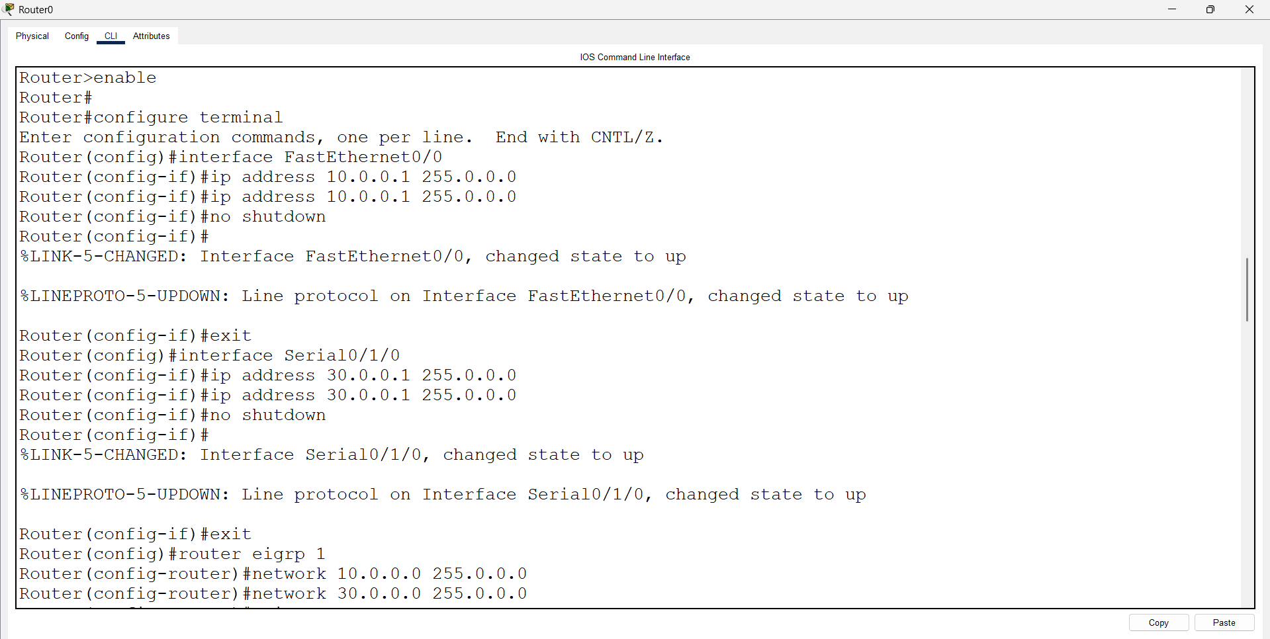
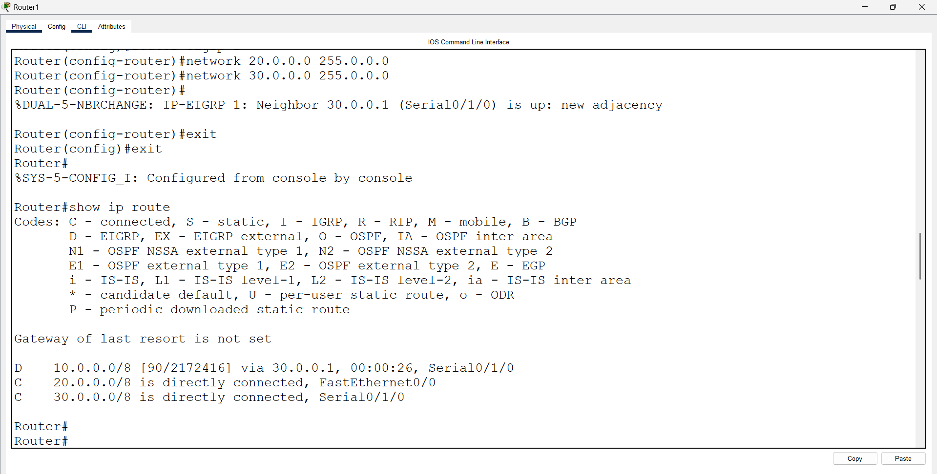
Open Router 1 – CLI prompt then type following commands
Router>enable
Router#configure terminal
Router(config)# interface fastEthernet 0/0
Router(config-if)# ip address 20.0.0.1 255.0.0.0
Router(config-if)#no shutdown
Router(config-if)#exit

Router(config)#interface Serial0/1/0
Router(config-if)#ip address 30.0.0.2 255.0.0.0
Router(config-if)#no shutdown
Router(config-if)#exit

Router(config)# router eigrp 1
Router(config-router)# network 20.0.0.0 255.0.0.0
Router(config-router)# network 30.0.0.0 255.0.0.0
Router(config-router)# exit
Router#show ip route
Router#show interface serial0/1/0

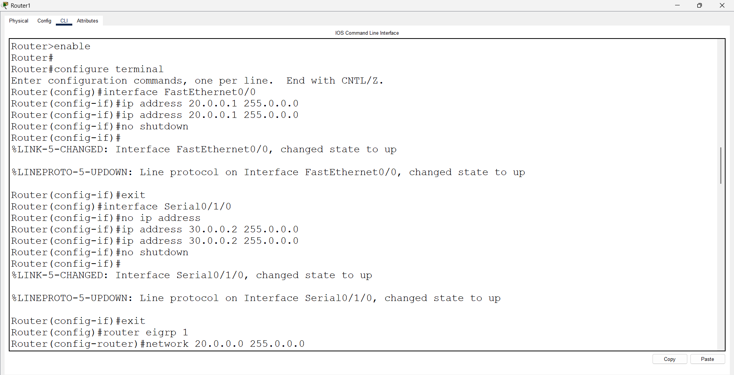

FastEthernet(crossover cable):
Open Router 0 – CLI prompt then type following commands
Router>enable
Router#configure terminal
Router(config)# interface fastEthernet 0/1
Router(config-if)# ip address 40.0.0.1 255.0.0.0
Router(config-if)#no shutdown
Router(config-if)#exit

Router(config)# router eigrp 1
Router(config-router)# network 10.0.0.0 255.0.0.0
Router(config-router)# network 30.0.0.0 255.0.0.0
Router(config-router)# network 40.0.0.0 255.0.0.0
Router(config-router)# exit
Router#show ip route
Router#show interface fa0/1
Open Router 1 – CLI prompt then type following commands
Router>enable
Router#configure terminal
Router(config)# interface fastEthernet 0/1
Router(config-if)# ip address 40.0.0.2 255.0.0.0
Router(config-if)#no shutdown
Router(config-if)#exit

Router(config)# router eigrp 1
Router(config-router)# network 20.0.0.0 255.0.0.0
Router(config-router)# network 30.0.0.0 255.0.0.0
Router(config-router)# network 40.0.0.0 255.0.0.0
Router(config-router)# exit
Router#show ip route
Router#show interface fa0/1

In load balancing, both routers must have the same bandwidth and delay.
Open Router 0 – CLI prompt then type following commands
Router>enable
Router#configure terminal
Router(config)# interface serial0/1/0
Router(config-if)# bandwidth 1000000
Router(config-if)#exit
Router(config)# interface serial0/1/0
Router(config-if)# delay 1000
Router(config-if)#exit
Router(config)# interface fa0/1
Router(config-if)# delay 1000
Router(config-if)#exit
Router(config)#exit
Router#show ip route

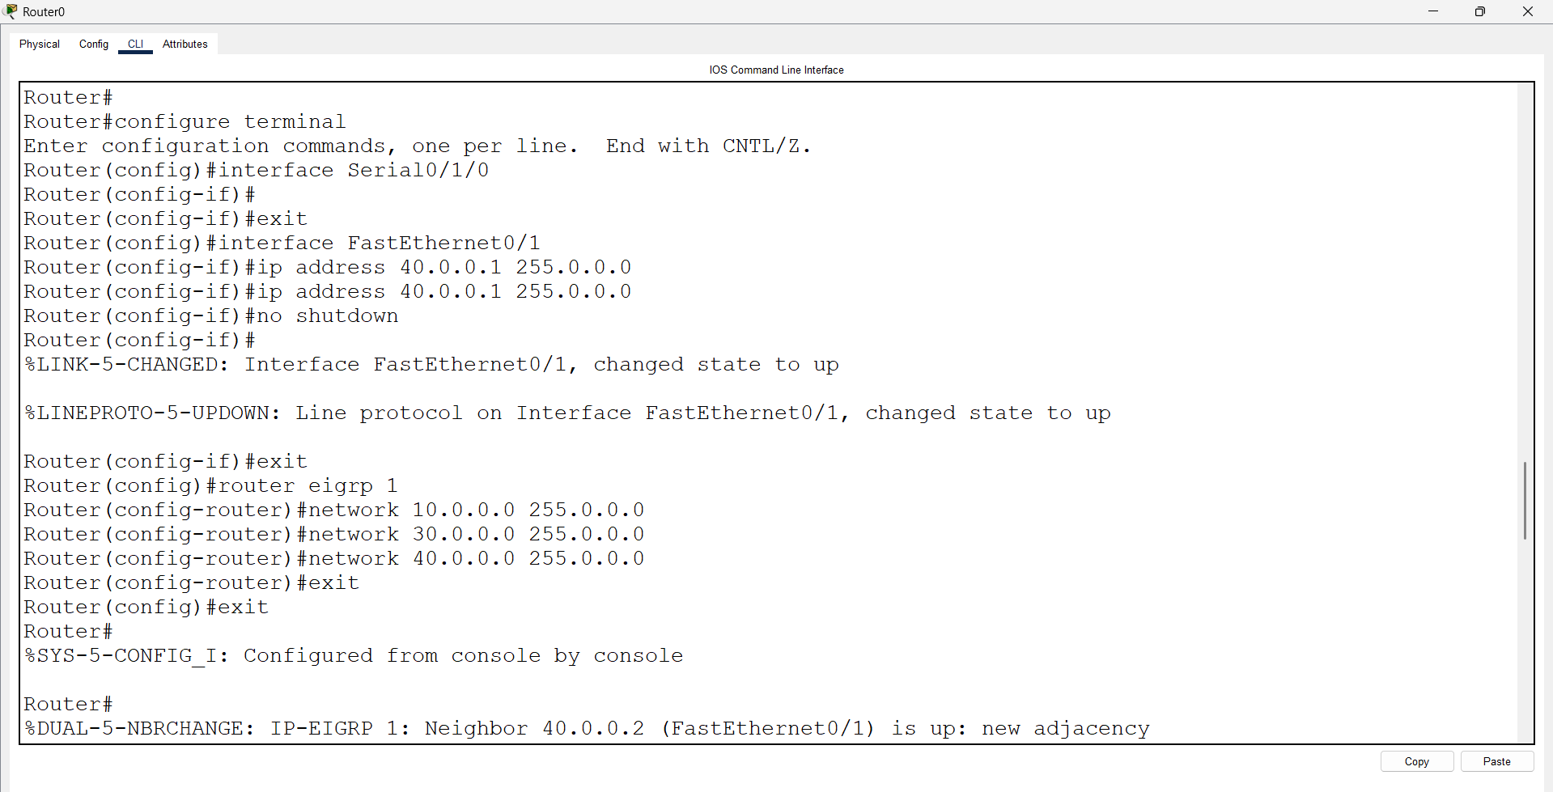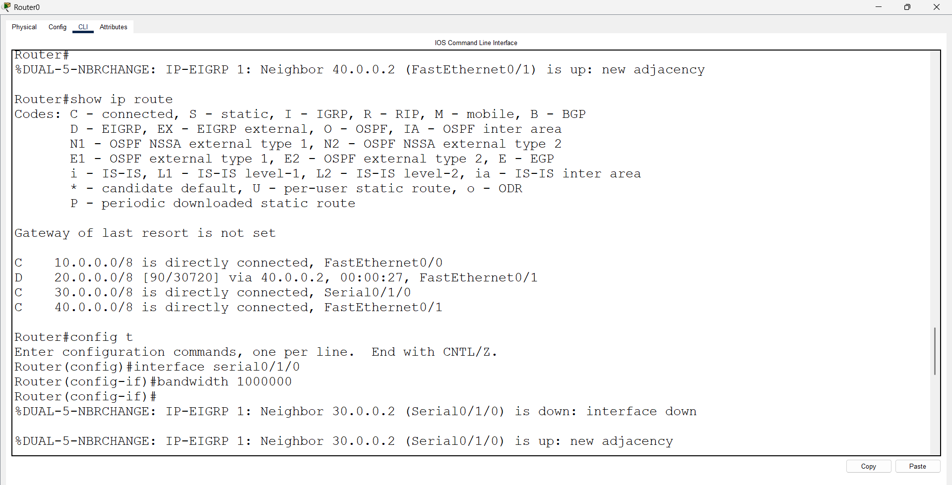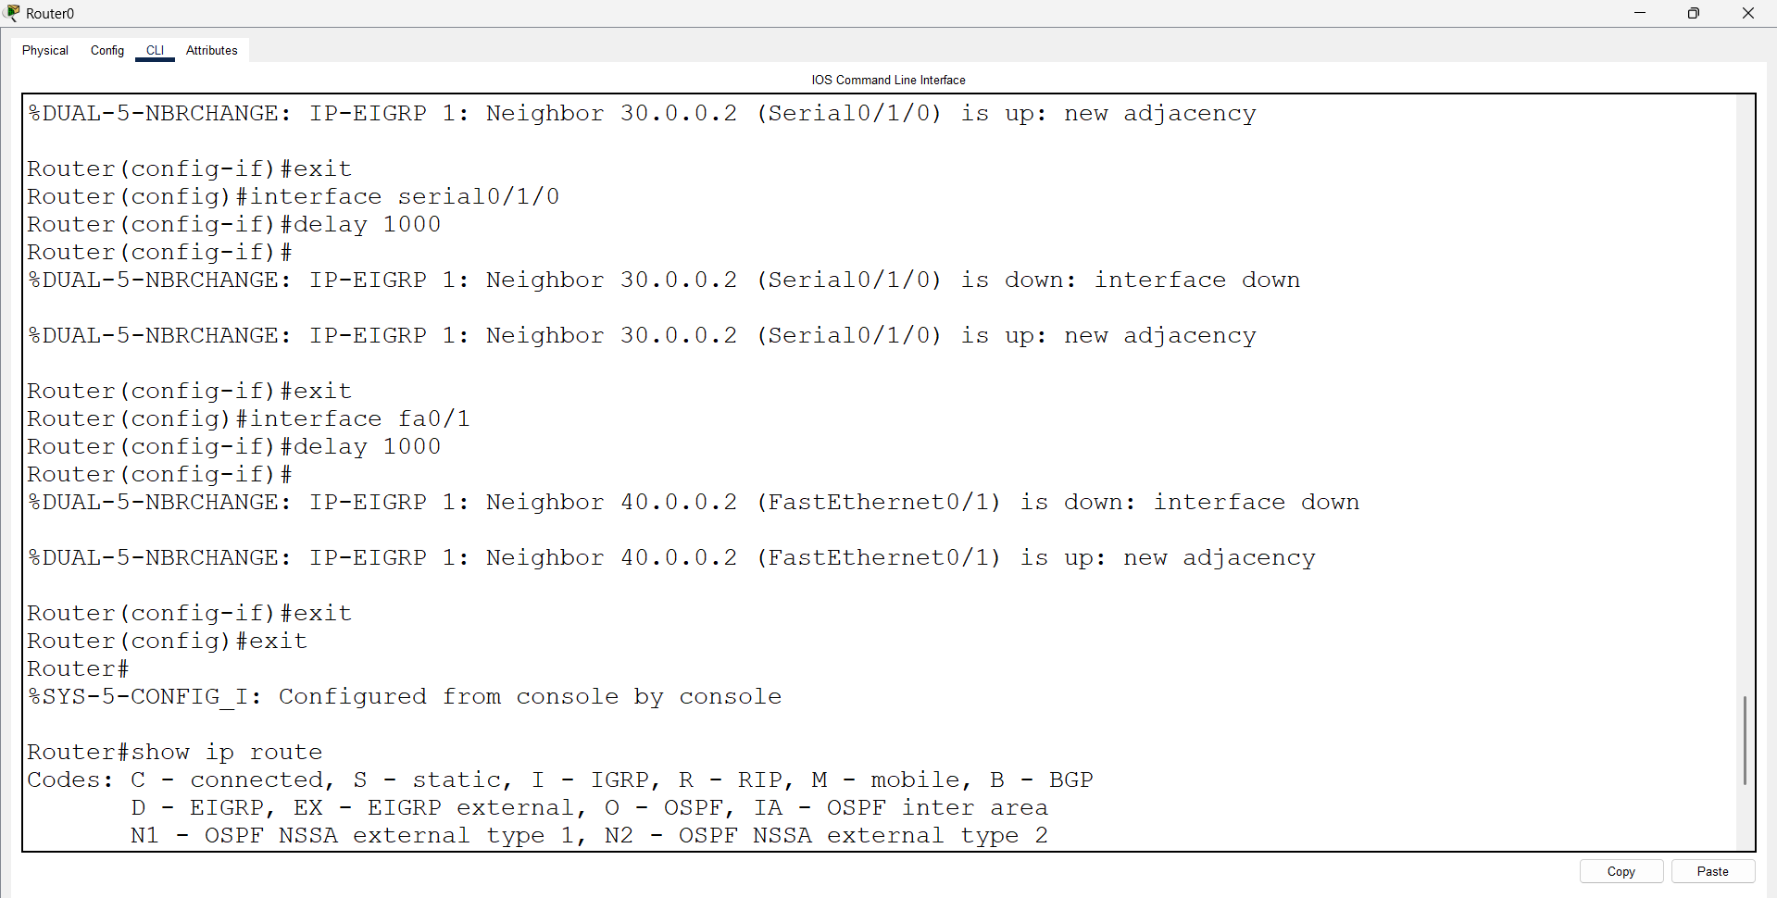
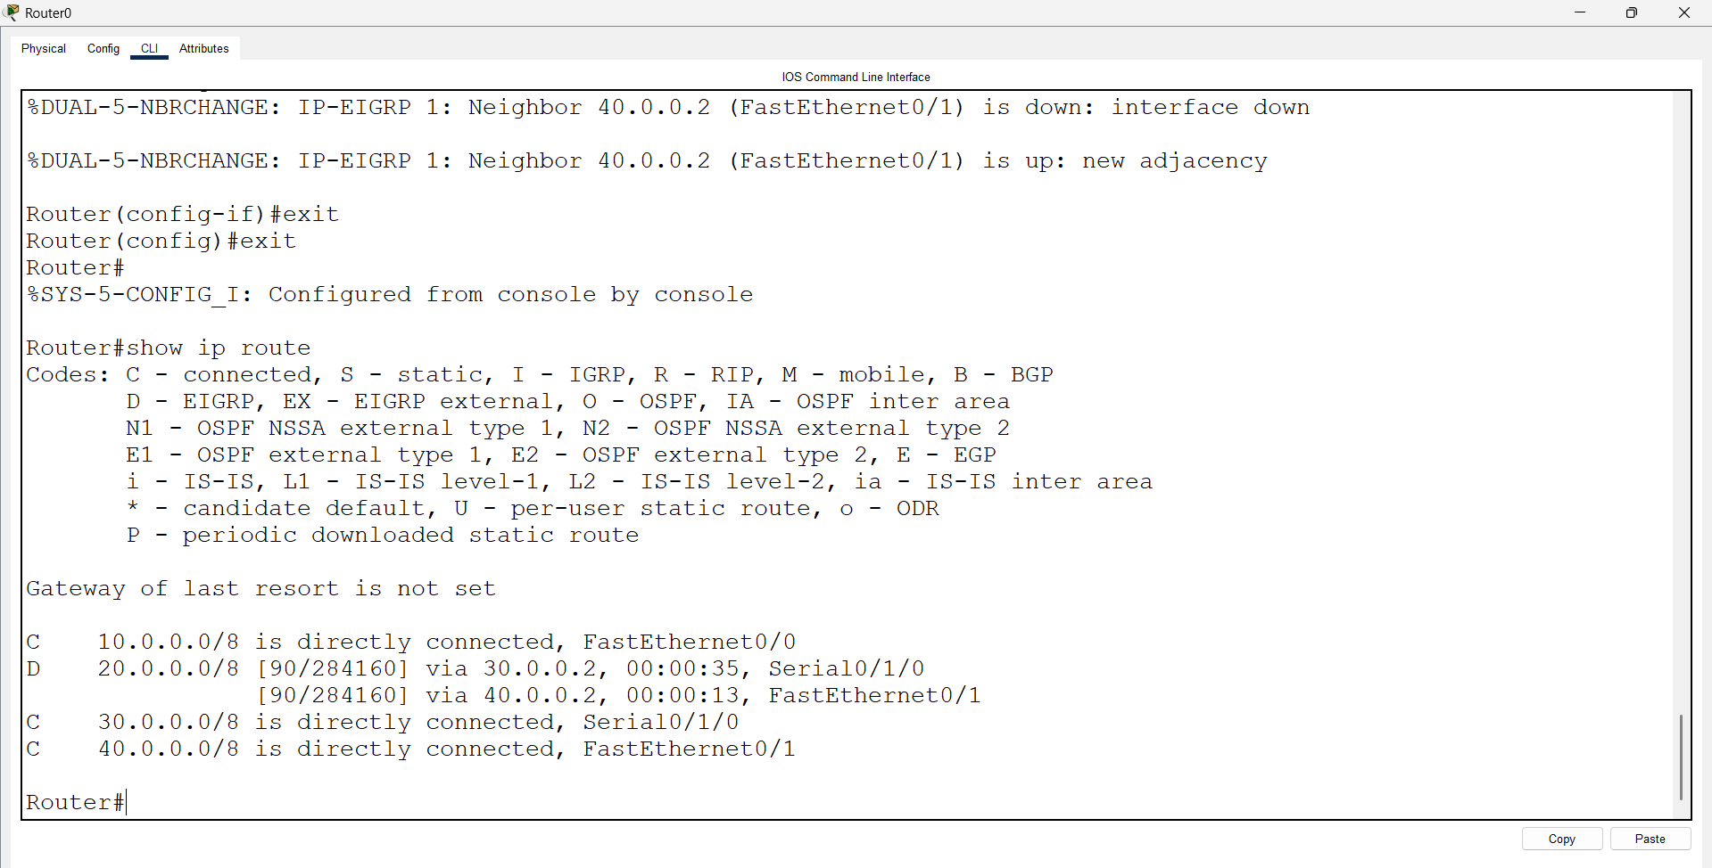
Open Router 1 – CLI prompt then type following commands
Router>enable
Router#configure terminal
Router(config)# interface serial0/1/0
Router(config-if)# bandwidth 1000000
Router(config-if)#exit
Router(config)# interface serial0/1/0
Router(config-if)# delay 1000
Router(config-if)#exit
Router(config)# interface fa0/1
Router(config-if)# delay 1000
Router(config-if)#exit
Router(config)#exit
Router#show ip route

